- Discuss the 5 main activities involved in Requirements Engineering Process.
1. Feasibility Studies - an estimate and study are made to see whether the system is feasible to be implemented in terms of economically, operationally and technically
2. Requirement Elicitation and Analysis – a process to work with stakeholders to derive their functional and non-functional requirements from the new system
3. Requirement Specification – a process to produce software requirements specification (SRS)
4. Requirement Validation – a process to show that the requirements actually define the system that client wants
5. Requirement Management – an ongoing process to management requirements (include management planning where policies and procedures for requirements management are designed and specified; change management where proposed requirements changes are analyzed and their impact are accessed)

- Nobiana specializes in swimwear and clothing for women. Started in 1995 as a small scale mail order company, Nobiana has now grown into a multi-million pound and award winning organization.

Working with an independent outsourcing consultancy Zen, Nobiana decided to implement a new point-of-sales and inventory management system. The new project was driven by the need to simplify the way in which stock information and point-of-sales applications were delivered to retail stores and to enable this to be easily scalable in order to accelerate roll-out to existing or new stores, reduce ongoing administration and support costs while providing real time and accurate view of stock across the business, minimizing stock levels and streamlining ordering across the branches.

  - Suggest and briefly explain 2 techniques for discovering requirements for the above project.
2 techniques:
- Prototyping
- Interviewing
- Open and closed questions may miss essential information
- Scenario
- Stakeholders usually find it easier to relate to real-life examples than abstract descriptions
- Scenarios may write in text plus diagrams. For e.g. Event scenario and Use-cases scenario
- Ethnography (Observation)
- an observational technique to understand social and organizational requirements
- Helps to discover implicit system requirements that reflect the actual rather than formal processes
- Focuses on end-users’ requirements only

Viewpoint-oriented analysis:
The viewpoint-oriented method used here is based on viewpoints, which are external to the system and the services delivered to these viewpoints. Data and control requirements for the services are also defined.

  - Assume that Zen is planning to adopt a viewpoint-oriented analysis method for the requirements analysis process. Describe viewpoint-oriented analysis in requirements analysis process.
Viewpoints can be used to classifying stakeholders and other sources of requirements.
3 generic types of viewpoints are:
- Interactor – people or other system that interact directly with the system
- Indirect – stakeholders who do not use the system themselves but who influence the requirements
- Domain – domain characteristics and constraints that influence the requirements.
Help to ensure get broad stakeholders’ coverage when discovering requirements.

  - Suggest 5 principal viewpoints which should be considered in the process of discovering requirements for the above project. Construct a viewpoint hierarchy to present your viewpoints.

5 principles viewpoints which might be take into account in the specification of the system.
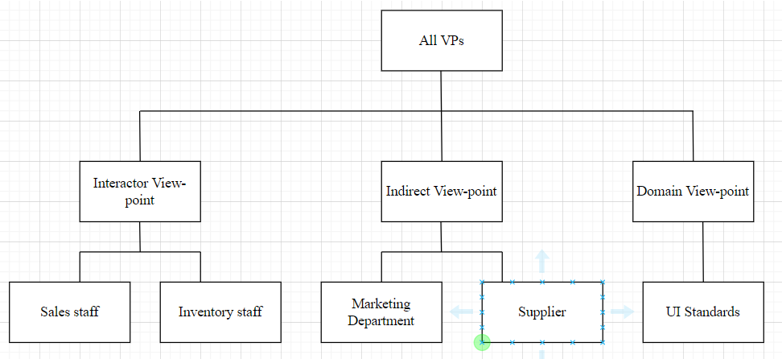

  - Discuss 2 advantages and 1 disadvantage of using viewpoint-oriented analysis method in requirement gathering and analysis.
2 advantages of viewpoints-oriented analysis
- To get the broad stakeholders coverage
- In majority interactive systems, it is natural to think of end-users as receivers of system services
- Relatively easy to decide if some agent is or not a valid viewpoint.

1 disadvantage
- Time consuming
- Tedious
- May be costly

  - Suggest 3 aspects to be checked when validating the SRS for the above-mentioned project.
- Completeness – include all functions needed
- Realism check – could be implemented (with existing technology, budget, schedule)
- Verifiability – to reduce potential dispute (demo that the delivered system meets each requirement)

- Discuss any 3 possible problems in Requirements Elicitation and Analysis process.
- Users/stakeholders are not clear on what they want from the computer system
- Users/stakeholders normally express requirements in their own terms
- Different Users/stakeholders have different requirements and they may express them in quite different ways
- Analysis takes place in an organizational context and political factors may influence the requirements of the systems
- The economic and business environment in which the analysis takes place is dynamic. It inevitably changes during the analysis process.

- Company KW is planning to develop an online document management system that is used by internal staff to store, share, and work on some confidential documents. You, and IT project manager, are responsible to manage this project with senior software engineers. Company KW requests you to deliver an initial version within 2 months and the subsequence increment within 2 months with active internal staff involvement.

Identify 3 viewpoints for the online document management system. Construct a viewpoint-oriented hierarchy for the system.
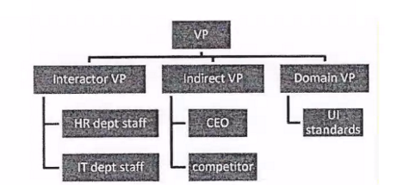

- Easy2Study.com is a global marketplace for teaching and learning online where students are mastering their skills. The system allows the students to search, view available courses, purchase, make payment, and join the courses. An access to start the course will be given once the payment is confirmed. Easy2Study.com is planning to extend their online system on mobile platforms to attract more customers as mobile users are increasing extremely.

As a software engineer for this project, you are required to prepare the system requirements document for Easy2Study.com mobile application. Recommend and explain 2 aspects that must be validated during Easy2Study.com SRS document validation process.
2 aspects:
- Validity – The functions of Easy2Study.com mobile application which user wanted is correct and confirmed needed.
- Consistency – There is no conflicting functions in Easy2Study.com mobile application
- Completeness – All functions needed in Easy2Study.com mobile application must be included

- Ladre is a small scaled family business found in 2000s which selling computers’ hardware and software. Recently the shop owner plans to improve the business by selling the products online. He has contacted your company as a suitable software house to handle this project.
Based on the case study, construct a viewpoint-oriented hierarchy for the online computer store system with 5 possible viewpoints. You must categorize your viewpoints under 3 categories (Interactor, Indirect, and Domain) with at least one viewpoint under each category.
